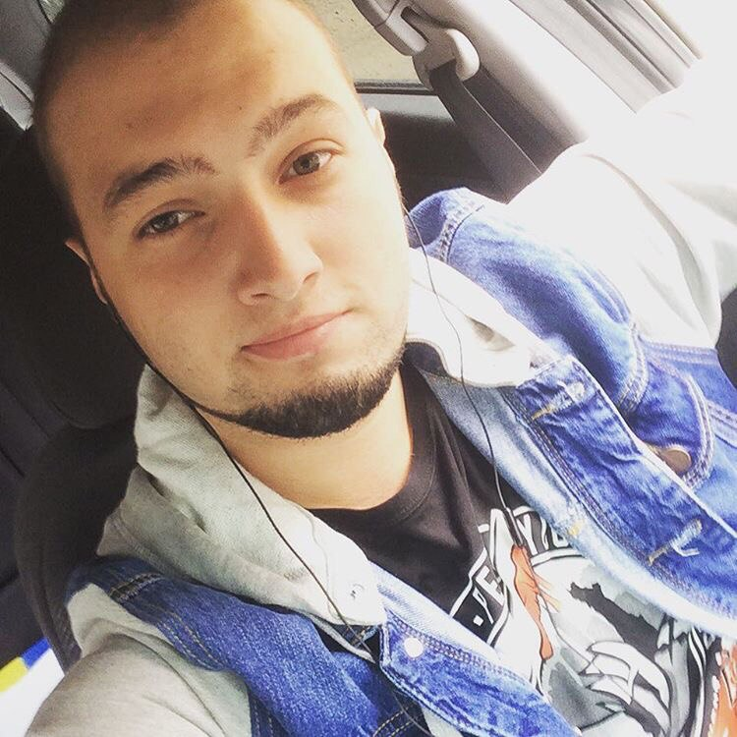

**Artemenko Vadim**

vad1kowned@gmail.com

**Desired position:** Motion, web and graphic designer

**About:**

Age: 22

Place of birth: Komsomolsk-on-Amur, Russia

Citizenship: Russian

Marital status: Single

**Languages:**

Russian — Native

English — Intermediate

Hebrew — B

**Education:**

Master: 2010-2014

Komsomolsk-on-Amur college information technology and service

Educational programme: Software of computer facilities and automated systems

**Skills:**

• Adobe Photoshop, Adobe Illustrator, Adobe After Effects, Cinema 4d

• MS Office

**Experience:** I worked in the service center for six months. Trained in the Ministry of Internal Affairs in Transport (MOI of Russia) in the role of assistant.

**Extracurricular activities:**

*Additional information:* There is no great work experience, because after college I entered the institute for the faculty of "construction", for the specialty "Construction of unique buildings and structures"

*Personal qualities:* **I want to grow up in design,** stressful, sociable and result-oriented

*Hobbies:*Music, serials, boxing, fitness, play on saxophone, tattoo, painting.